New Analytics Document –

Project Purpose –
Goal:
Build a real-time breaking news system that:
- Ingests live news as soon as it’s published
- Detects urgent or “breaking” news automatically
- Sends alerts to editors or subscribers instantly
- Stores all news for analytics and historical records
Why breaking news detection is important:
- Editors and users need critical events first, e.g., political updates, disasters, sports results
- Reduces reaction time → better coverage and decision-making
- Provides historical data for trends, analytics, and insights
Real-World Sources of News: News API
Step 1: News Ingestion (Producer Lambda)
- How it works:
  - News API or reporter app sends the news to API Gateway
  - Producer Lambda is triggered
  - Lambda formats the news (adds timestamp, category, priority)
  - Lambda pushes the news into Kinesis Data Stream
- Purpose:
  - Make all news events streaming in real-time into a central system
  - Acts as a “post office” for news
Step 2: Real-Time Streaming (Kinesis Data Stream)
- What happens:
  - Kinesis stores incoming news in shards (like lanes on a conveyor belt)
  - Allows multiple consumers to read the same news simultaneously
  - Handles high throughput of real-time news
- Purpose:
  - Ensure news flows continuously, reliably, and in order
  - Multiple consumers (alerts, analytics) can subscribe
Step 3: Breaking News Detection (Consumer Lambda)
- Consumer Lambda reads each news event from Kinesis
- Checks for breaking news using:
  - priority field from API or reporter
  - Keyword-based rules (“breaking”, “resigns”, “earthquake”)
  - Optional: AI/NLP (Amazon Comprehend) for urgency detection
- If breaking news:
  - Sends alert to SNS → email, Slack, or push notifications
- Otherwise:
  - For general news, stores in S3 via Firehose for analytics
- Purpose:
  - Filter important events for immediate attention
  - Ensure editors/users don’t miss critical news
Step 4: Alerts (SNS / Email / Slack / Push)
- SNS topic receives breaking news from Consumer Lambda
- Sends notifications:
  - Email to editors
  - Slack/Teams notification to newsroom
  - Optional mobile push notifications
- Purpose:
  - Real-time delivery of critical news
  - Reduces latency between news creation and user awareness
Step 5: Storage & Analytics (Firehose → S3)
- Kinesis Firehose automatically streams all news events to S3
- Stores JSON or CSV files for:
  - Historical records
  - Trend analysis (category, region, urgency)
  - Machine learning pipelines for predictions
- Purpose:
  - Maintain complete history
  - Supports future reporting, dashboards, and insights
Step 6: Monitoring (CloudWatch Logs)
- Producer and Consumer Lambda automatically log to CloudWatch
- Logs include:
  - News processed
  - Alerts sent
  - Errors or failed records
- Optional metrics & alarms:
  - Number of breaking news alerts per hour
  - Lambda errors, Kinesis throughput
- Purpose:
  - Ensure system is working correctly
  - Quickly troubleshoot issues

Reporter / News API → API Gateway → Producer Lambda → Kinesis Data Stream
│
├─ Consumer Lambda → SNS → Email / Slack / Mobile Alerts
│
└─ Firehose → S3 → Analytics / Dashboard

STEP-BY-STEP IMPLEMENTATION
News API
↓
Producer Lambda (fetches live news)
↓
Kinesis Data Stream
↓
Consumer Lambda
├── If BREAKING → Email alert (SNS)
└── Log everything → CloudWatch

STEP 0: PREREQUISITES
You need:
- AWS Account
- Python 3.11 Lambda
- A News API key (example: newsapi.org – free)
STEP 1: CREATE KINESIS DATA STREAM
- Go to Kinesis → Data Streams
- Create stream:
  - Name: news-stream
  - Shards: 1
- Create
👉 This is the real-time pipe

STEP 2: CREATE SNS TOPIC (FOR EMAIL ALERT)
- Go to SNS → Topics
- Create topic:
  - Name: breaking-news-topic
- Create subscription:
  - Protocol: Email
  - Endpoint: your email
- Confirm email
👉 This sends breaking news alerts

✅ STEP 3: PRODUCER LAMBDA (FETCH LIVE NEWS)
🔹 Purpose
- Fetch live news from News API
- Push each article into Kinesis
🔹 Create Lambda
- Name: news-producer-lambda
- Runtime: Python 3.11
- Timeout: 30 sec
- Permissions:
  - kinesis:PutRecord
  - logs:*
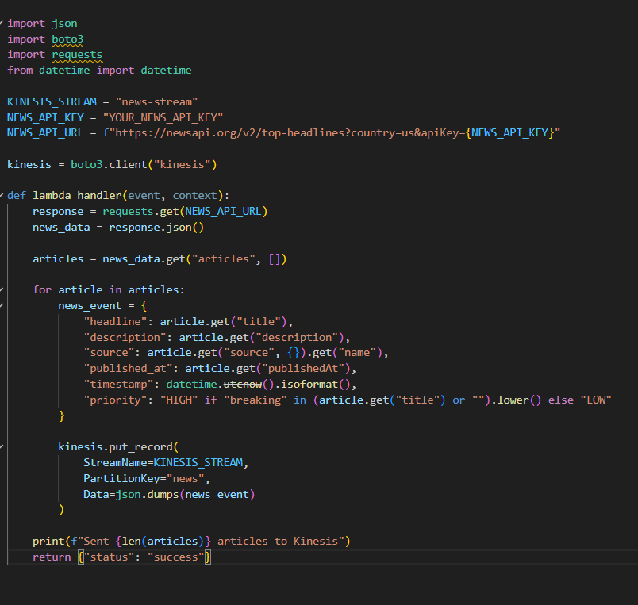
STEP 4: AUTOMATE PRODUCER (NO MANUAL RUN)
🔹 Use EventBridge (CloudWatch Schedule)
- Go to EventBridge
- Create rule:
  - Schedule: every 5 minutes
- Target:
  - news-producer-lambda
👉 Producer Lambda now automatically fetches live news
STEP 5: CONSUMER LAMBDA (BREAKING NEWS DETECTION)
🔹 Purpose
- Read news from Kinesis
- Detect breaking news
- Send email alert
- Log everything

🔹 Create Lambda
- Name: news-consumer-lambda
- Runtime: Python 3.11
- Permissions:
  - sns:Publish
  - logs:*
ADD KINESIS TRIGGER
- Source: news-stream
- Batch size: 10
- Starting position: Latest
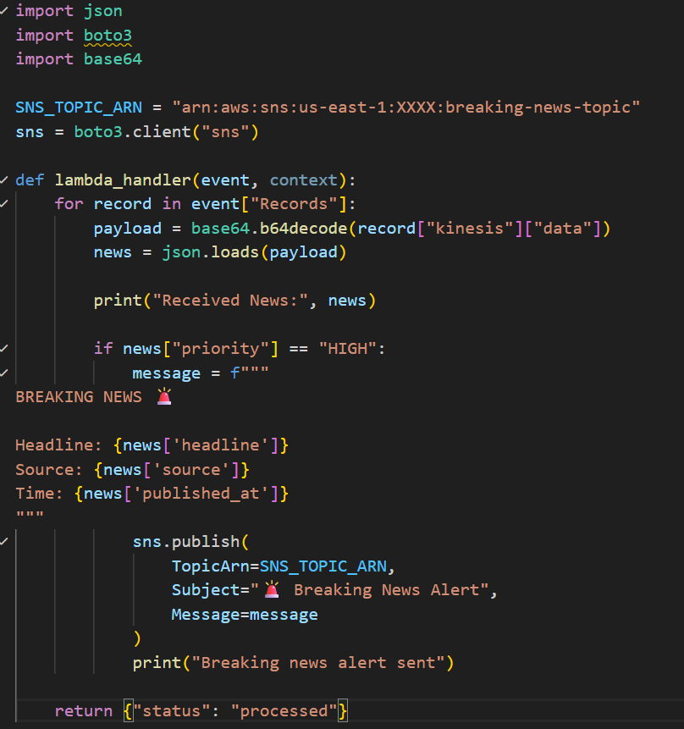
STEP 6: CLOUDWATCH LOGS (DEBUG & MONITOR)
🔹 Where to check logs
- Go to CloudWatch → Log groups
- Check:
  - /aws/lambda/news-producer-lambda
  - /aws/lambda/news-consumer-lambda
🔹 What you see
- News ingested
- News processed
- Alerts sent
- Errors if any
STEP 7: TESTING (IMPORTANT)
🔹 Test Producer
- Wait for EventBridge trigger OR click Test
- Check CloudWatch logs
- Verify records in Kinesis
🔹 Test Consumer
- Once Producer sends data → Consumer auto-triggers
- If headline contains “breaking”
✅ You receive email

